Chapter 6: Cells

6.1 All living things are made up of cells

Student worksheet answers (pages 96–97)

Cells

1 Who made one of the first microscopes?

Robert Hooke

2 What did this scientist discover by looking at cork?

Plant cells

3 What scientific field of study did this scientist create in their work?

Microbiology

4 What are the three principals of cell theory?

All organisms are composed of one or more cells; cells are the basic unit of life and structure; new cells are created from living cells

5 What is a unicellular organism? Give an example.

An organism that is made up of one cell; *Examples given may vary.* Examples include bacteria, prokaryotes, archaea, some fungi

6 What is a multicellular organism? Give an example.

A living organism that has more than one cell; *Examples given may vary.* Examples may include humans, fleas, cork, insects

7 What is the function of the membrane of a cell?

It is the surface of the cell that allows nutrients in and wastes out

8 How does a cell maximise the function of the cell membrane

Cells benefit from the relatively large surface area of the cell membrane to maximise the ability to take in nutrients and remove wastes

9 What is the relationship between the amount of surface area and the volume of a cell called?

Surface area to volume ratio

10 Explain why smaller cells are better able to survive.

They have a larger surface area compared to their volume

11 Which of the cells below has a larger surface area to volume ratio? Explain your answer.

The cell in diagram b has a larger surface area compared to its volume, which is due to its irregular shape

Extend your understanding

12 A cube with 4 cm base, height and width is shown in diagram a. Diagram b shows the same cube cut into 8 identical cubes, each with a 2 cm base, height and width.

Formulas for a cube:

Surface area (*SA*) = 6 ´ (base ´ height)

Volume (*V*) = base ´ height ´ width

Use the given formulas to answer the following questions.

a Calculate the surface area of the larger cube (diagram a)

*SA* = 6 ´ (*b* ´ *h*) = 6 ´ (4 ´ 4) = 96 cm2

b Calculate the volume of the larger cube (diagram a)

*V* = *b* ´ *h* ´ *w* = 4 ´ 4 ´ 4 = 64 cm3

c Calculate the combined surface area of the 8 smaller cubes (diagram b)

*SA* single cube = 6 ´ (*b* ´ *h*) = 6 ´ (2 ´ 2) = 24 cm2

*SA* 8 cubes = 24 ´ 8 = 192 cm2

d Calculate the combined volume of the 8 smaller cubes (diagram b)

*V* single cube = *b* ´ *h* ´ *w* = 2 ´ 2 ´ 2 = 8 cm3

*V* 8 cubes = 8 ´ 8 = 64 cm3

e Which diagram has a larger volume?

Both have the same volume

f Which diagram has a larger surface area?

The smaller cubes in diagram b have a larger overall surface area

g Which would be more effective at absorbing nutrients? Explain your answer.

The smaller cubes would be more effective due to their larger surface area; this means that smaller objects would be able to absorb nutrients and remove wastes more effectively

6.2 Microscopes are used to study cells

Student worksheet answers (pages 98–99)

Microscopes

1 Label the parts of this microscope in the spaces provided.

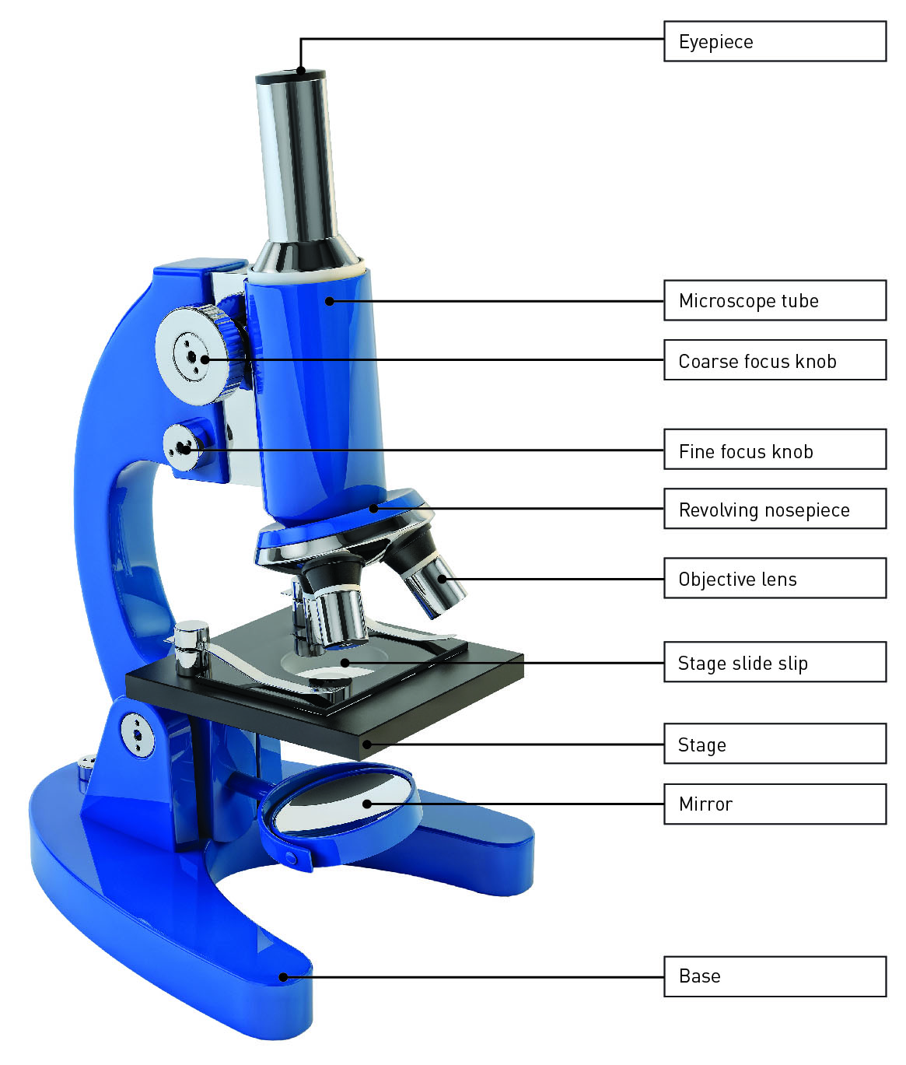

2 What are the three types of microscopes?

Compound light microscope, stereo microscope and scanning electron microscope

3 Why are there three objective lenses on a compound light microscope?

To view objects at different magnifications

4 Complete the table below to summarise the main differences between the three types of microscopes.

|  |  |  |  |
| --- | --- | --- | --- |
|  | **Compound Light Microscope** | **Stereo Microscope** | **Scanning Electron Microscope** |
| **What is it used to observe?** | Thin slices of specimens | Larger specimens | Tiny specimens |
| **What is its magnification?** | 1500 times | 200 times | 1–50 million times |
| **DIMENSION** | 2D image | 3D image | 3D image |
| **Can it see through an object or only the surface?** | Light can pass through a specimen | Surface of a specimen | Surface of a specimen |
| **Can it be used to see cells or whole organisms?** | Cells and cell structures | Whole organisms | Surfaces of cells; parts of a whole insect or smaller |

Extend your understanding

5 Complete the following magnification calculations.

a eyepiece magnification 10, objective lens 10

10 ´ 10 = 100´ magnification

b eyepiece magnification 10, objective lens 20

10 ´ 20 = 200´ magnification

c eyepiece magnification 10, objective lens 40

10 ´ 40 = 400´ magnification

6 What happens to the magnification of the microscope as you double the objective lens magnification?

It doubles

7 Complete the following magnification calculations.

a eyepiece magnification 10, objective lens 10

10 ´ 10 = 100´ magnification

b eyepiece magnification 5, objective lens 10

5 ´ 10 = 50´ magnification

c eyepiece magnification 10, objective lens 20

10 ´ 20 = 200´ magnification

d eyepiece magnification 5, objective lens 20

5 ´ 20 = 100´ magnification

8 What happens to the magnification of the microscope as you halve the ocular lens magnification?

The magnification halves, as long as you use the same objective lens

6.3 Plant and animal cells have organelles

Student worksheet answers (pages 100–103)

Cell organelles

1 What is a cellular organelle? Give an example and state its function.

Organelles are mini-organs that have specialised function within the cell

*Examples will vary.* Example includes mitochondria – where energy is produced within the cell

2 What is the function of the following cellular structures?

a cell membrane

Skin of a cell, forms a barrier, allows nutrients in and wastes out

b cytoplasm

Jelly-like fluid inside the cell, contains nutrients and waste

c DNA

Contains the instructions for every job the cells do

3 Label the organelles in the animal cell below.

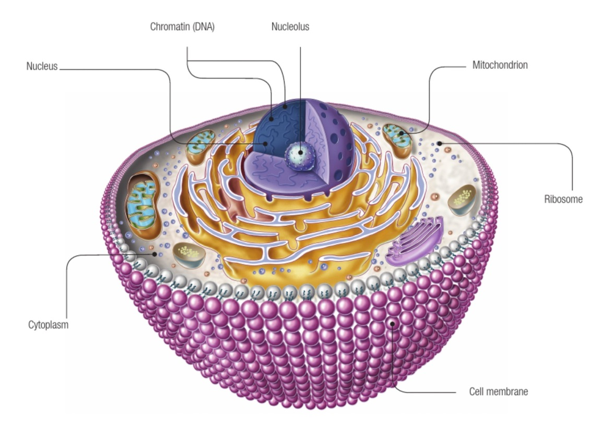

4 Label the organelles in the animal cell below.

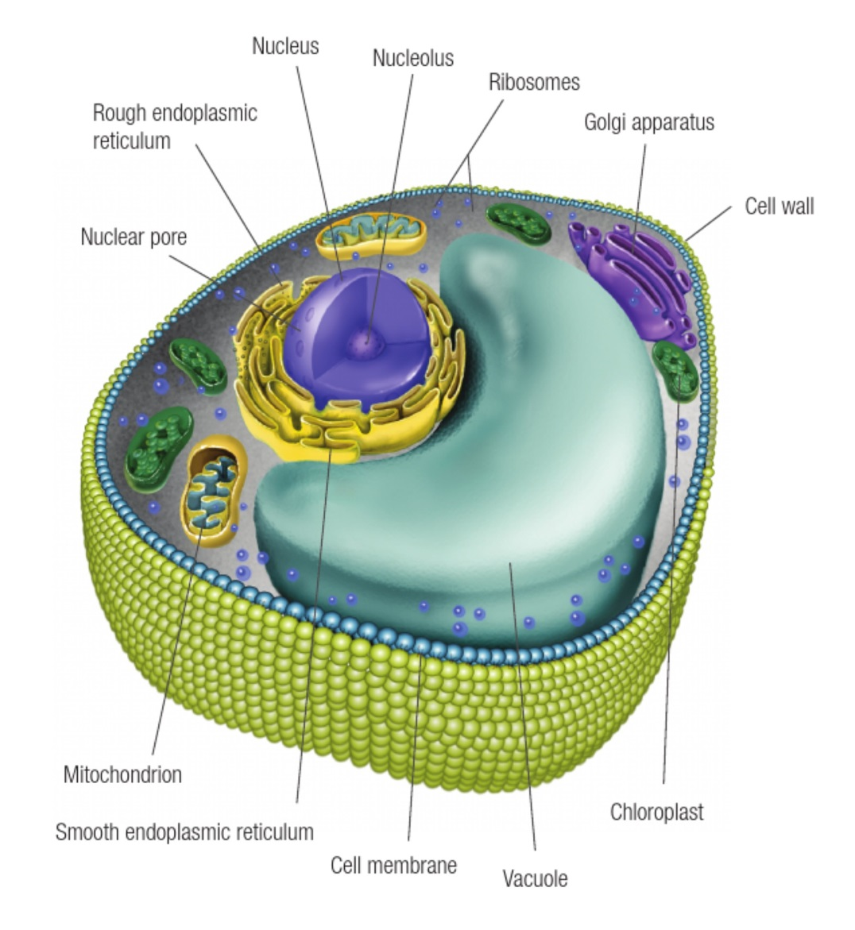

5 Complete the following Venn diagram by identifying which organelles belong to plants, animals or both.

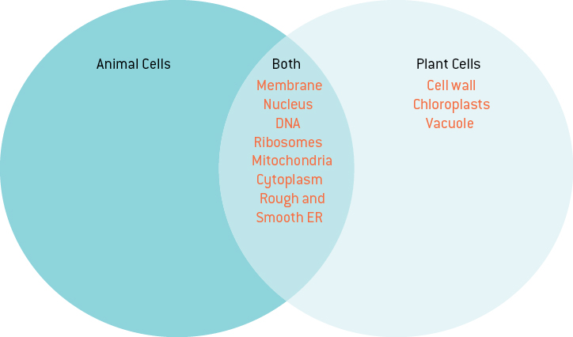

Extend your understanding

The chart below compares the size of different cells found in the human body.

6 For each cell, determine how big it is using the scale on the chart and write your answer below. You must measure from left to right, i.e. the length or diameter of the cell.

a Human egg cell (ovum):

100 µm

b White blood cell:

13–15 µm

c Red blood cell:

8 µm

d Cell from inside cheek:

28–30 µm

e Human sperm cell:

30 µm

f Human hair cross-section:

30 µm

Microbiologists measure the size of cells based on the magnification of the microscope they are looking through. The three images below show cells observed through a microscope.

7 Using the measuring bar below, measure the size of each of the following cells.

|  |  |  |
| --- | --- | --- |
| Pink cell:  2.6 µm  Red cell:  2.9 µm  Green cell:  1.8 µm | Height of the middle cell:  1.8 µm  Width of the middle cell:  0.9 µm  Width of any green chloroplast:  0.15 µm | Width of a frog egg:  2.2 µm  Width of the nucleus (black):  0.5 µm |

6.4 All organisms have cells that specialise

Student worksheet answers (pages 104–105)

Specialised cells

1 Cells are classified into what two main groups?

Prokaryotic and eukaryotic cells

2 Create a list of the characteristics of these two main groups of cells.

|  |  |
| --- | --- |
| **PROKARYOTIC** | **EUKARYOTIC** |
| Primitive | Complex |
| Kingdom Monera (bacteria) | Found in four kingdoms |
| No nucleus | Contain a nucleus |
| DNA floats free in cytoplasm | Contain most membrane-bound organelles |
| Unicellular | Multicellular |

3 The following statements about the characteristics of cells in the five kingdoms are wrong. Explain why each statement is wrong.

a Cell walls are found only in Plants.

Cell walls also present in Fungi, Monera and some Protists

b Chloroplasts are present in all Protists.

Chloroplasts are only present in some Protists and all Plants

c Ribosomes are absent in the cells of all kingdoms.

Ribosomes are present in the cells of all kingdoms

d All kingdoms have multicellular organisms.

All Monera are unicellular, and so are some Protists and Fungi

e All kingdoms have cells that contain a nucleus.

Monera have no nucleus

f Large vacuoles are present only in plants.

Large vacuoles are present in some Protists

g Mitochondria are present in Monera.

Mitochondria are absent in Monera

h Only some cells have genetic material.

All cells have genetic material

Extend your understanding

4 State which kingdom the following cells belong to.

|  |  |
| --- | --- |
| Protist – amoeba, page 105 | Plant – chloroplast, page 103 |
| Animal – sperm cell, page 100 | Protist – paramecium, page 105 |
| Animal – intestinal cells, page 100 | Fungi – typical fungi cell, page 104 |

6.5 Bacteria are single-celled organisms

Student worksheet answers (pages 106–107)

Bacteria – Kingdom Monera

1 How many cells make up a single bacterial organism?

One

2 How much non-human life is inside an average adult’s large intestine at any given time?

1 kilogram

3 What is a pathogen?

A microorganism that can potentially cause a disease

4 What does it mean to be contagious?

When the pathogen can be passed from one organism to another

5 What is a host?

An organism on which another organism lives

6 What is a symptom of a disease?

Changes that occur to an individual as a consequence of the disease

7 What are three possible disease symptoms?

Answers will vary. Examples include swelling, redness, and pus

8 What are harmful microbes?

Microbes that invade the body and cause disease

9 What are four types of microbes?

Bacteria, fungi, protists, viruses

10 For each of the four microbe types identified in question 9, give two examples of each.

Answers will vary. Possible answers may include:

· Fungi – tinea (athletes foot), ear infections

· Protists – malaria, dysentery

· Bacteria – tuberculosis (TB), pneumonia, Legionnaires’ disease, cholera

· Viruses – common cold, flu, measles, herpes

11 Are viruses living or non-living?

They are non-living pathogens

12 What is the difference between a virus and a cell?

A virus is a microbe that lives inside a cell

13 Why is it hard for our immune system to fight viruses?

Viruses hide in cells, which makes it harder for our immune system to find and fight them

14 What is the process of cell division in bacteria called?

Binary fission

15 Why should your fridge be operated at 4ºC or lower?

Most bacterial growth stops below 4ºC

16 Why should your food be cooked at 60ºC or higher?

Most bacterial growth stops above 60ºC

Extend your understanding

17 The following graph shows the number of specific bacterial cells present in a person during a   
one-week period.

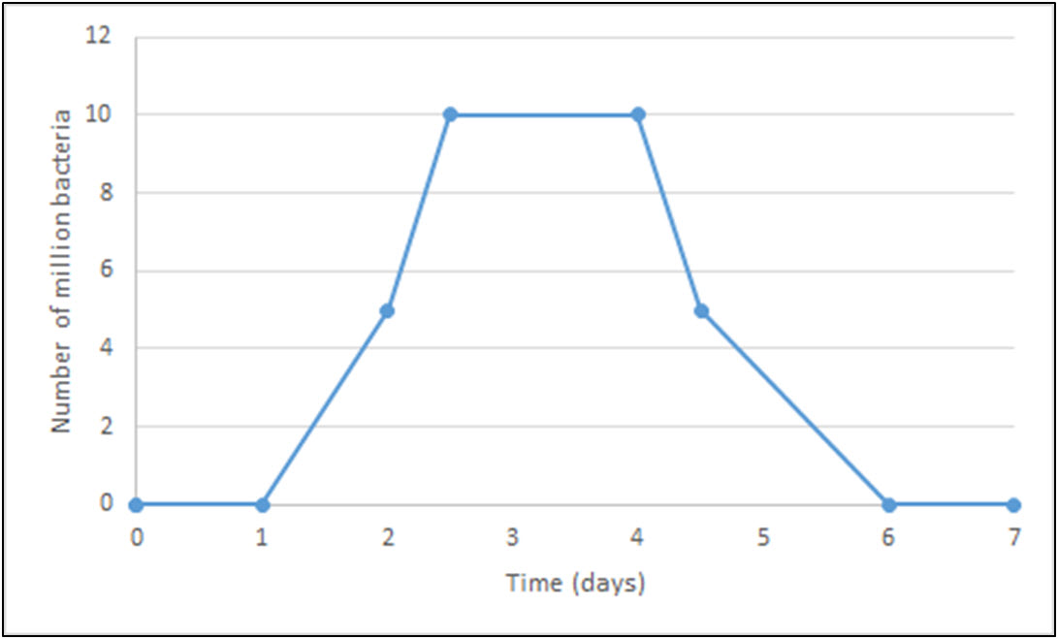

a When was the person producing the most of this bacteria?

Between Day 1 and Day 2

b What process was responsible for this growth?

Binary fission

c When did this bacterial growth stop?

During Day 2

d What reason can you give for the bacterial growth stopping?

Answers may vary*.* Possible answers include antibiotics or the body’s immune response.

e At what temperature was this bacteria growing?

At body temperature, 37ºC

6.6 Eukaryotic cells undergo mitosis

Student worksheet answers (pages 108–109)

Mitosis

1 What is the purpose of DNA?

It holds the instructions for all cellular jobs

2 Where is DNA stored?

In the nucleus

3 What must happen before a cell splits to reproduce?

DNA must replicate (make a copy) of itself

4 What is mitosis?

The process of cell division

5 What is the difference between a parent and daughter cell?

A parent cell is the original; this will then divide into two identical daughter cells

6 Draw a diagram to show the process of mitosis.

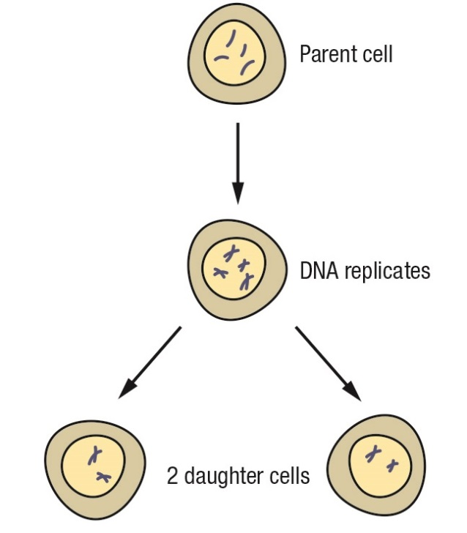

7 What is cancer caused by?

Uncontrolled cell division

8 What happens to cells when they reach the end of their life? What is this process called?

The cell will die or be destroyed; this process is called apoptosis

9 What is the difference between a mutagen and a carcinogen?

A mutagen is a substance or method that can damage or alter DNA, such as radiation, viruses or chemicals. When the damage or alteration to DNA causes cancer, the mutagen is a called a carcinogen.

10 What is a tumour?

When cell division gets out of control, a lot of cells grow and form a mass known as a tumour

11 What is a secondary cancer?

When cells break free from the tumour and spread throughout the body to destroy other organs

12 What are the two types of tumour?

Benign and malignant

13 What are the characteristics of each type of tumour?

Benign tumours do not spread and are not normally fatal; malignant tumours spread throughout the body and can be fatal if spread is not stopped

Extend your understanding

14 Tasmanian devils are prone to a life threatening condition called TDFTD (Tasmanian devil facial tumour disease). This disease results in tumours around the face and neck. It can be transmitted from devil to devil due to their aggressive fighting behaviours in which they bite each other around the face.

a What type of tumour causes TDFTD?

Malignant

b What effect does this tumour have on the Tasmanian devil?

Causes tumours around the face and neck

c In most cases, the devils do not die from the cancer itself but from side effects caused by this cancer. Considering the information above, what might two of these effects be?

Difficulty breathing (suffocation) and difficulty eating (starvation)

d Why is Tasmania creating an insurance population?

To breed healthy Tasmanian devils that are separated from the wild population; they cannot fight with infected devils and therefore remain free from TDFTD

e Why would it be beneficial to cull the infected population?

To eradicate the disease before it can spread further.

6.7 Fungal cells can save lives

Student worksheet answers (pages 110–111)

Using cells to save lives

1 Why were injuries so dangerous in the early 1900s and before?

Any scratch or cut to the skin could result in an infection. Before the 1900s, there were no medications to kill these infections so they often resulted in death.

2 What is a key property of some moulds that makes it essential to medicine?

Some moulds stop the growth of bacteria that is responsible for infection

3 What discovery was made in 1928 and who made this discovery?

Mould prevents bacterial growth – Alexander Fleming

4 Why is it said that this discovery was an accident?

Fleming was investigating bacterial growth and did not clean up properly before leaving for a holiday. Upon returning, he discovered that bacteria could not grow where a small spot of mould had formed. He concluded that the mould (*Penicillium*) was stopping the bacteria from growing.

5 How does penicillin stop bacterial growth/infection?

Penicillin stops the bacteria from repairing or making a new cell wall

6 Which two scientists developed a method to isolate penicillin?

Howard Florey and Ernest Chain

7 What were the outcomes of the initial experiment used to determine if penicillin had been isolated?

Mice were infected with streptococcal bacteria, but only those treated with penicillin survived

8 Use your knowledge to determine why human trials were conducted after animal trials.

Animals are often first used as models instead of humans because human life is considered to be more valuable

9 What were the scientists rewarded with for the isolation of penicillin for medicinal use?

A Nobel Prize in 1945

10 Use the penicillin timeline on page 111 of your student book to state the event that occurred in the following years.

a 1000

Moulds and fermented materials were used to treat infections

b 1870

Louis Pasteur discovered that mould prevented anthrax from growing

c 1871

Joseph Lister discovered that urine stoped bacterial growth

d 1897

Ernest Duchesne discovered mould prevented bacterial growth in animals

e 1922

Fleming discovered that tears (containing lysozyme) also prevented bacterial growth

f 1928

Fleming discovered that mould also prevented bacterial growth

g 1930s

Florey and Chain isolate penicillin from mould and use it on patients

Extend your understanding

11 The case of penicillin is a perfect example of the scientific method.

a State the problem that Fleming was trying to overcome.

To prevent infections caused by bacteria

b What would Fleming’s hypothesis have been, regarding the mould and bacteria?

Prediction: That mould prevents bacterial growth

c What results did he obtain from his research that supported his hypothesis?

Bacteria did not grow where the mould was growing, implying that the mould stopped bacterial growth

12 Analyse the experiment conducted on mice by Florey and Chain and answer the following questions.

a State the problem that Florey and Chain were trying to overcome.

The chemical in mould that prevented bacterial growth needed to be isolated

b What would Florey and Chain’s hypothesis have been, regarding penicillin and streptococcal bacteria?

Prediction: That the administration of penicillin stops streptococcal bacterial growth

c What results did they obtain from their research that supported their hypothesis?

The mice administered with penicillin recovered, but the other mice died from the bacterial infection

d How were their findings used to change the course of history?

They had isolated a medicine that fought infections. This was especially important as it was completed just before the beginning of World War II, and was used on battlefields.